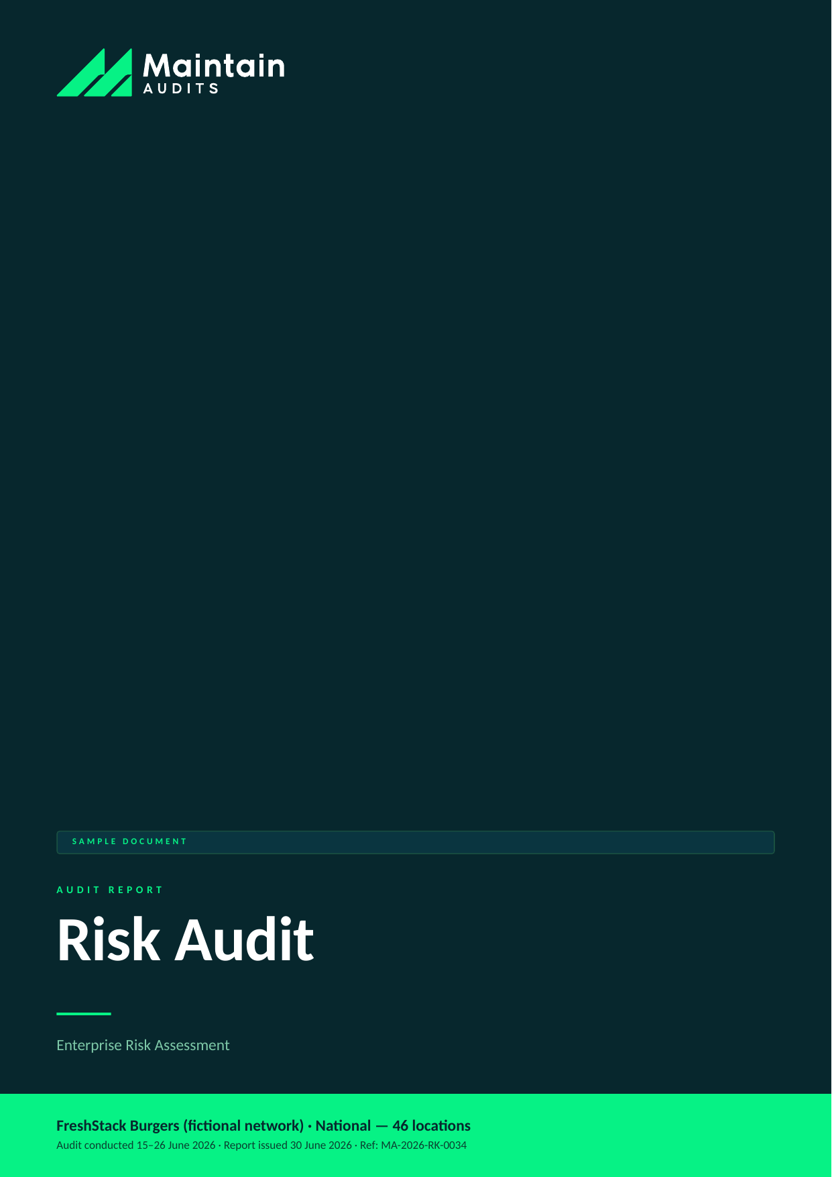

Client (fictional) | FreshStack Burgers (fictional network)
Location | National — 46 locations
Audit type | Risk Audit
Audit conducted | 15–26 June 2026
Report issued | 30 June 2026 (48-hour turnaround)
Lead auditor | D. Lindqvist, Principal Consultant — Maintain Audits
Report reference | MA-2026-RK-0034
Distribution | Franchisor head office; franchisee principal — Commercial in confidence

SAMPLE DOCUMENT — all client details and findings are fictional, prepared to demonstrate Maintain Audits' reporting format.

SECTION 1 │ EXECUTIVE SUMMARY

This enterprise risk audit assessed 14 risk categories across the FreshStack Burgers national network of 46 locations over an 11-day review period combining site visits, data analysis, and franchisor interviews. Six priority risks were identified across two criticality levels.
The two Critical findings define the risk picture. First: a single franchisee generating approximately 24% of network revenue is under financial stress, creating a concentration risk the network currently has no formal process to monitor or mitigate. Second: allergen handling is inconsistent across the network, with three confirmed near-misses in the preceding 12 months that the network's incident process did not formally register as allergen events. These two findings require action within 48 hours and 30 days respectively.
The four High and Medium findings — POS fleet end-of-support, single-source supply, wage compliance, and declining review sentiment — are all manageable with structured programs and clear ownership. The network has the capability to close all six risks; what has been missing is a formal risk register and a cadence for reviewing it.

Overall Result
Measure | Result
Risks assessed | 14 categories assessed
Priority risks identified | 6 (2 Critical, 2 High, 2 Medium)
Overall rating | High
Most urgent action due | Franchisee concentration risk review — RK-01 (within 48 hours)

Findings by Risk Rating
Rating | Count
Critical | 2
High | 2
Medium | 2

SECTION 2 │ SCOPE & METHODOLOGY

A structured enterprise risk review across 14 risk categories, combining financial data analysis, supply chain review, operational site visits, digital sentiment analysis, and compliance record review.

In Scope
- Financial risk — franchisee concentration, network-level cash flow, franchisor entity health
- Operational risk — supply chain resilience, staffing and wage compliance
- Brand and reputational risk — customer sentiment, social media, review trajectory
- Compliance risk — food safety, allergen management, employment law
- Technology risk — POS and systems currency, data security posture
- Strategic risk — competitive positioning, network growth pipeline

How the Audit Was Conducted
- Financial data review: franchisee P&L submissions, network royalty data, accounts receivable aging
- Supply chain interviews: primary suppliers for top 10 menu SKUs; logistics review
- Regulatory review: Fair Work compliance data, food safety incident register
- Technology review: POS fleet census, software version audit, security posture check
- Digital analysis: Google, social, and delivery-platform review data for all 46 locations
- On-site visits at 8 locations (selected by financial performance and geographic spread)

Risk Rating Scale
Rating | Meaning | Action required
Critical | Immediate threat to safety, legal compliance, or brand integrity. | Within 48 hours
High | Material non-compliance likely to cause customer, safety, or financial impact. | Within 7 days
Medium | Non-compliance with franchise standards; manageable if addressed promptly. | Within 30 days
Low | Minor deviation or housekeeping issue. | Within 90 days
Observation | Not a non-compliance; an improvement opportunity worth acting on. | At next review

SECTION 3 │ FINDINGS SUMMARY

ID | Area | Finding | Rating
RK-01 | Financial risk | Single franchisee at ~24% of network revenue is under financial stress | Critical
RK-02 | Compliance risk | Inconsistent allergen handling — 3 near-misses not formally registered | Critical
RK-03 | Technology risk | POS fleet: 31% of devices on end-of-support software | High
RK-04 | Operational risk | Single-source supplier for hero bun — no approved alternate | High
RK-05 | Compliance risk | Wage compliance — 4 of 8 visited sites had incomplete time records | Medium
RK-06 | Brand risk | Review sentiment declining across the network for 3 consecutive quarters | Medium

SECTION 4 │ DETAILED FINDINGS

CRITICAL | RK-01 — Single franchisee at ~24% of network revenue is under financial stress

Rating | Area | Standard / reference | Remediate by
Critical | Financial risk | Franchise Agreement cl. 12; network risk policy | Within 48 hours

What we found: One franchisee operating 11 of 46 network locations — contributing approximately 24% of total royalty revenue — is carrying a debt position that, based on submitted financials, gives it less than 8 weeks of operating runway at current burn. This franchisee's distress is not widely known within the network. If this entity enters administration, the impact on the franchisor's revenue, supply chain commitments, and brand would be material.
Evidence: Franchisee P&L submissions (June 2026); accounts receivable aging report; site visit observations at two of the franchisee's locations.
Recommended action: Within 48 hours: convene an urgent meeting with the franchisee principal and the franchisor's legal and financial advisors to understand the full position. Assess whether intervention, restructure, or managed transition is the appropriate response. Do not allow this risk to continue without active management. In parallel, establish a formal franchisee financial health monitoring framework so concentration risk of this magnitude is identified earlier.
Responsible: Franchisor CEO / legal counsel

CRITICAL | RK-02 — Inconsistent allergen handling — 3 near-misses not formally registered

Rating | Area | Standard / reference | Remediate by
Critical | Compliance risk | Food Standards Code; FA cl. 7.3; network food safety std | Within 30 days (matrix); 48 hrs (process fix)

What we found: Allergen management practice varied significantly across the 8 visited sites — from excellent (dedicated equipment, staff briefing, allergy register) to inadequate (no separate utensils, no verbal confirmation protocol). Review of the incident register identified three customer complaints in the preceding 12 months that described potential allergen exposure; none were classified as allergen incidents in the register. A serious allergen event carries legal, regulatory, and reputational consequences the network cannot absorb.
Evidence: Site observations at 8 locations; incident register review; customer complaint file.
Recommended action: Within 48 hours: implement an interim allergen-incident classification protocol and brief all store managers. Within 30 days: complete an allergen compliance audit at all 46 locations using the updated matrix (to be developed by the food safety team). Establish mandatory allergen training as part of new-staff onboarding. The three unregistered near-misses should be reviewed with legal counsel to assess notification obligations.
Responsible: Network food safety manager / franchisee principals

HIGH | RK-03 — POS fleet: 31% of devices on end-of-support software

Rating | Area | Standard / reference | Remediate by
High | Technology risk | Network technology std; PCI-DSS requirements | Within 30 days (remediation plan)

What we found: 14 of 46 locations are running POS software versions that reached end-of-support in December 2025 — meaning no security patches are being issued for these devices. These devices process customer payment card data. Running unsupported POS software is a PCI-DSS compliance breach and creates exposure to payment fraud and data theft.
Evidence: POS fleet census conducted remotely with the network's technology provider; software version report.
Recommended action: Within 30 days: present a remediation plan for the POS fleet upgrade to the franchisor board, with funding model and timeline. The upgrade can be sequenced by risk — prioritising the highest-volume locations — but must be complete within 12 months. The technology provider has indicated bulk pricing is available at network scale.
Responsible: Network technology manager / franchisee principals

HIGH | RK-04 — Single-source supplier for hero bun — no approved alternate

Rating | Area | Standard / reference | Remediate by
High | Operational risk | Network supply chain policy s.3 | Within 60 days

What we found: The network's hero burger bun — used in the top 3 revenue SKUs — is sourced exclusively from a single national bakery supplier. No alternate supplier has been qualified. A supply disruption (industrial action, recall, logistics failure) would immediately affect the ability to sell the network's primary products. This risk materialised briefly in February 2026 when a 3-day production delay caused short supply at 12 locations; no contingency was available.
Evidence: Supply chain interviews; procurement records; February 2026 supply incident report.
Recommended action: Within 60 days: identify and commence qualification of at least one alternate bun supplier capable of supplying at network scale within 48 hours of activation. The qualification process should include product match (spec, size, cost), logistics capability, and a test order. Maintain a minimum 5-day buffer stock policy at network level.
Responsible: Network supply chain manager

MEDIUM | RK-05 — Wage compliance — 4 of 8 visited sites had incomplete time records

Rating | Area | Standard / reference | Remediate by
Medium | Compliance risk | Fair Work Act; Fast Food Industry Award | Within 30 days

What we found: At 4 of 8 visited sites, employee time records were either incomplete (missing break records or clock-out times) or stored in a format not reconcilable with the rostering system. Fair Work investigations in the QSR sector have increased significantly in 2025–26; inadequate records make underpayment claims effectively impossible to defend.
Evidence: Time record review at visited sites; roster system audit.
Recommended action: Within 30 days: issue a wage compliance directive to all franchisees requiring time records to be complete, digital, and reconcilable with payroll for a minimum of 7 years. Conduct a self-audit process across all 46 locations using the Fair Work self-assessment tool. Consider engaging a specialist payroll auditor for the highest-risk locations.
Responsible: Network compliance manager / franchisee principals

MEDIUM | RK-06 — Review sentiment declining across the network for 3 consecutive quarters

Rating | Area | Standard / reference | Remediate by
Medium | Brand risk | Network brand standard; franchisor KPIs | Within 30 days

What we found: Average Google review rating across the network has declined from 4.1 to 3.7 over the preceding three quarters. Delivery platform ratings show a similar trend. Qualitative analysis of review text identifies three recurring themes: wait times, order accuracy, and staff attitude. These are operational metrics — the product itself is not the driver of the decline.
Evidence: Sentiment data pull across all 46 network locations; delivery platform data; qualitative text analysis (600 reviews sampled).
Recommended action: Within 30 days: establish a monthly review sentiment dashboard reported to the franchisor support team and shared with franchisees. Identify the 10 lowest-rated locations for targeted operational support. Address wait time and accuracy through operational standard tightening rather than marketing spend — the product quality is not the issue.
Responsible: Network operations manager

SECTION 5 │ WHAT'S WORKING WELL

An audit should recognise strength as clearly as it flags risk. The following practices met or exceeded the network standard:

- Product quality consistency across visited sites was strong — the core menu items delivered to specification at 7 of 8 visited locations
- The network's supply chain for all secondary ingredients (condiments, packaging, beverages) is well-diversified with multiple approved suppliers
- New franchisee onboarding documentation and training materials are comprehensive and current
- Three high-performing franchisees demonstrate what excellent network citizenship looks like — their practices are worth codifying and sharing

SECTION 6 │ REMEDIATION ROADMAP

Actions are sequenced by risk. Maintain Audits can verify closure of each item through a follow-up desktop review or re-inspection.

ID | Action | Owner | Due
RK-01 | Urgent franchisee review; establish financial health monitoring framework | Franchisor CEO / legal | Within 48 hours
RK-02 | Allergen incident classification fix (48 hrs); full network allergen audit (30 days) | Food safety manager / franchisees | 48 hours / 30 days
RK-03 | POS fleet upgrade remediation plan to board | Technology manager / franchisees | Within 30 days
RK-04 | Qualify alternate bun supplier; implement buffer stock policy | Supply chain manager | Within 60 days
RK-05 | Wage compliance directive; self-audit across all locations | Compliance manager / franchisees | Within 30 days
RK-06 | Review sentiment dashboard; targeted support for lowest-rated locations | Operations manager | Within 30 days

SECTION 7 │ NEXT STEPS & ONGOING MONITORING

- RK-01 escalation path to be confirmed within 24 hours; Maintain Audits available to support the franchisee review process
- RK-02 allergen protocol briefing confirmation within 48 hours
- Recommend establishing a formal Risk Register with quarterly review cadence — this audit can provide the template
- Full risk re-assessment recommended at 6-month mark to measure closure progress

Questions about this report: info@maintainaudits.com.au · +61 414 530 836 · maintainaudits.com.au

This report is a sample document prepared by Maintain Audits, a division of Maintain Technology, for demonstration purposes. All client names, locations, personnel, and findings are fictional. Actual audit reports are prepared under our engagement terms and are confidential to the client. This document does not constitute legal, financial, or professional compliance advice.

